**LAB#6**

**Example:**

/*Facts*/

parent(molly, charlie).

parent(molly, fred).

parent(molly, george).

parent(molly, ginie).

parent(weasely, charlie).

parent(weasely, fred).

parent(weasely, george).

parent(weasely, ginie).

parent(harry , albus).

parent(harry,severus).

parent(ginie, albus).

parent(ginie, severus).

male(weasely).

male(harry).

male(charlie).

male(fred).

male(george).

male(albus).

male(severus).

female(molly).

female(ginie).

/* rules */

mother(X, Y) :-

parent(X, Y),

female(X).

father(X, Y) :-

parent(X, Y),

male(X).

child(X, Y) :-

parent(Y, X).

partner(X, Y) :-

child(Z, X),

child(Z, Y),

X \= Y.

grandparent(X, Y) :-

parent(X, Z),

parent(Z, Y).

grandchild(X, Y) :-

grandparent(Y, X).

grandfather(X, Y) :-

grandparent(X, Y),

male(X).

grandmother(X, Y) :-

grandparent(X, Y),

female(X).

son(X, Y) :-

child(X, Y),

male(X).

daughter(X, Y) :-

child(X, Y),

female(X).

sibling(X, Y) :-

parent(Z, X),

parent(Z, Y),

X \= Y.

sister(X, Y) :-

sibling(X, Y),

female(X),

X \= Y.

brother(X, Y) :-

sibling(X, Y),

male(X),

X \= Y.

uncle(X, Y) :-

brother(X, Z),

child(Y, Z).

aunt(X, Y) :-

sister(X, Z),

child(Y, Z).

nephew(X, Y) :-

aunt(Y, X),

male(X);

uncle(Y, X),

male(X).

niece(X, Y) :-

aunt(Y, X),

female(X);

uncle(Y, X),

female(X).

**OUTPUT:**

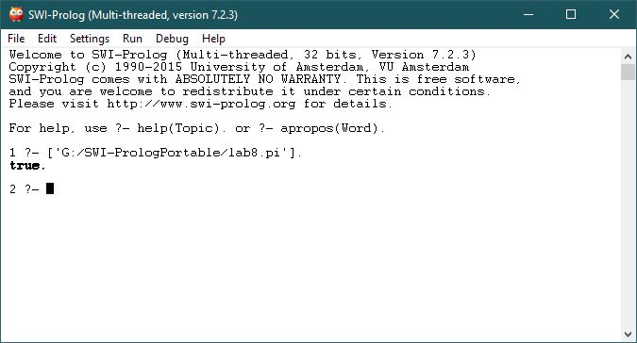

**Question#1**

Draw your family tree or any family tree taking dummy values on sheet of paper starting from grandparents till second generation.

**Solution:**

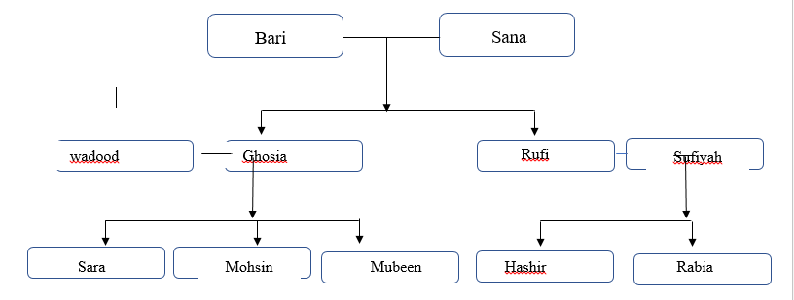

**QUESTION#2**

Write a prolog code for the family tree for every possible relation ( refer to above code). Compile and run it. Also attach results which shows following :

* All facts you have declared.
* Check the facts

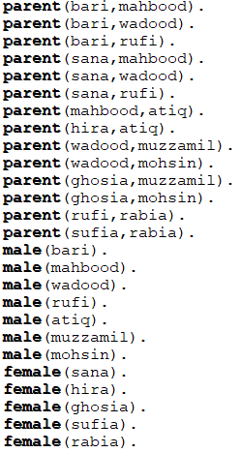**SOLUTION:**

**QUESTION#3:**

Test your program for all the rules as described in the example family tree program of lab?

**SOLUTION:**

